PGR Student’s Guide - Nomination of Examiners

Approval of Final Title and Nomination of Examiners
- Approximately three months prior to your thesis submission deadline, you and your supervisor need to complete the Approval of Title and Nomination of Examiners online forms.
Overview of the process
- Student submits final title and abstract.
- Supervisor nominates examiners
- Head of School approval
- PG Dean approval

- You need to provide your exact final title of your thesis (ensure your wordings and spellings are correct!)
- Provide a very short summary of your area of research (approximately 6 words), suitable for use in a graduation ceremony.
- You must upload an abstract for your thesis as part of your submission.
- Your supervisor will then complete their online form, which includes nominating examiners and providing evidence of their suitability in relation to examining your thesis. Usually an internal and an external examiner will be appointed. For staff candidates, two external examiners are appointed (for junior members of staff, at the discretion of the Dean of Postgraduate Studies, one external and one internal may be appointed). These forms then go to Head of School & PG Dean for approval.
- You can monitor progress via the ‘Summary’ tab (see below).
- For more detail on procedures and requirements please see the Student Progress Website.

Submitting your Form
Log on to your ePortfolio and click on the Nomination of Examiners icon. This will take you to the form and links to further guidance on the Student Progress site.
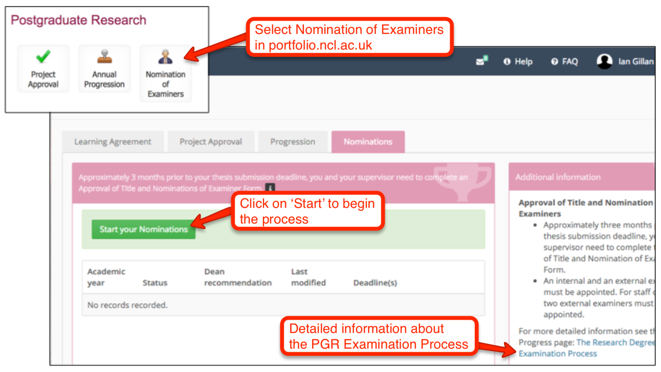

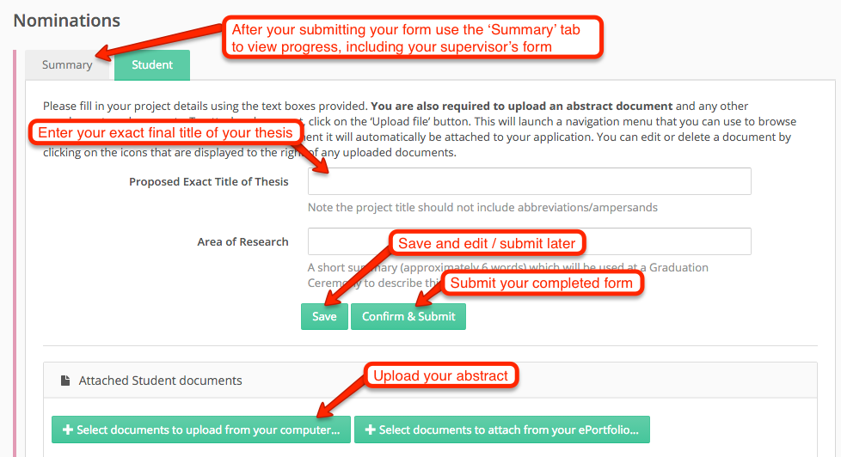

Procedural questions: contact your Graduate School. Technical problems: contact it.servicedesk@ncl.ac.uk

