eProgression – Guide for Panel members
If you have been assigned as a panel member to one or more students, you will need to use the eProgression system in order to access documentation in advance of the panel meeting, and to report on the outcome of the panel meeting.

The Online Submission Process

Log into the system
When both student and supervisor have completed their forms you will receive an email requesting you to complete the panel review of a student’s Annual Progression, which will include a direct link to the form. Alternatively you can access this at https://postgrad.ncl.ac.uk. Use your usual campus username and password to log in.
From the home page you will see if there are any outstanding progressions for you to complete in your role as a panel member. If applicable, you will also see outstanding tasks if you are a supervisor or Head of School/nominee.
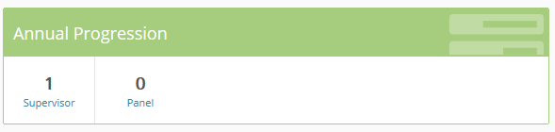
Listed below this summary box will be two tabs, showing your students and your panel students.
You can access records through either route.
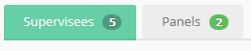

Access student records
You can access a particular student’s record in one of two ways:
- By selecting them from the list of your panel students.
- By selecting the number of students with you in the Annual Progression box. This will show a list of all students currently with you for comment, and you will then need to view their record using the ‘View record’ button.

View the records
Use the ‘view records’ link against the progression item to view a summary of the progression. If both the student and supervisor have completed their forms, then you will be able to view the details submitted by them. If they remain outstanding, then you will unable to view them.
You can download the forms together using the ‘Download forms’ button at the top of the panel section of progression. 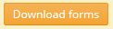.

Completing the progression report
If you are responsible for completing the panel report, select the panel tab and complete the relevant fields and comments.
Use the ‘Save’ button to save your entry and return to it later.

Submit the form
Once you and any other panel members have fully and properly completed the form, use the ‘Confirm & Submit’ button to finally submit your feedback. Remember you are submitting on behalf of the panel!

Additional features of the Website
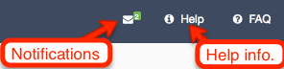
In the Notifications section you can see all the messages sent to you from this system. There is also online context sensitive help.

Student Profile
The profile for each of your students includes:
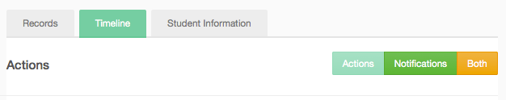
- Records – a list of records relating to Project Approval, Annual Progression and Nomination of Examiners.
- Timeline – a chronological list of actions (dates of submissions for student, supervisors, panel, HoS etc) and you can also see notifications.
- Student Information – including registration information from SAP SLcM (this data will be at least one day behind, with automated updated in the evenings of working days).

Further Information
Progression Guidelines:
https://newcastle.sharepoint.com/hub/sp/Pages/progression.aspx
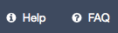
See also the inline help and FAQ or view instructions at:
https://reflect.ncl.ac.uk/help/pgr

For questions about requirements and procedures please contact your School/Graduate School.
Graduate School (Faculty of HaSS and SAgE)
gradschool@ncl.ac.uk

Graduate School (Faculty of Medical Sciences)
medpg-enquiries@ncl.ac.uk

For technical problems please contact IT Service Desk:
it.servicedesk@ncl.ac.uk or tel. (0191 222) 85999

