# 

# Using your ePortfolio

A guide by a student, for students

[ 1](#_Toc369179961)

[Using your ePortfolio 1](#_Toc369179962)

[Introduction to your ePortfolio 2](#_Toc369179964)

[Why should I use my ePortfolio? 3](#_Toc369179965)

[Accessing your ePortfolio 4](#_Toc369179966)

[My Blog 5](#_Toc369179967)

[My Communities 9](#_Toc369179968)

[My Skills 12](#_Toc369179969)

[My CV 17](#_Toc369179970)

[Your File Store 20](#_Toc369179971)

[Action Plan 21](#_Toc369179972)

[My Meetings 22](#_Toc369179973)

[Sharing 29](#_Toc369179974)

[Profile 32](#_Toc369179975)

[What to do now 33](#_Toc369179976)

‘*The ePortfolio is easy to access and simple to use!’*

*‘I can see how I’ve progressed and become more professional.’*

# Introduction to this guide

My name is Charlotte Pople-Hoskins, and I am a second year student at Newcastle University. I produced this how-to guide on ePortfolio during my Newcastle Work Experience (NWE) placement within the University.

I undertook research aimed at finding out **what students think** the main benefits of using their ePortfolio are. This research included focus groups of previous users of ePortfolio pilot projects and a survey of over 90 other users of the system, and there are references and quotes from them throughout this guide.

I have written this guide based on my research, to show you what the ePortfolio can do and why it is worth using. I’ve structured it so that you can either read the whole guide or go straight to the section that you want to know more about.

I hope you will enjoy reading this brochure and find the ePortfolio a valuable tool during your university career.

# Introduction to your ePortfolio

Your ePortfolio is your online workspace, designed as somewhere you can write reflections on your work, goals and achievements.

It is designed to support your **reflective learning**. This means ways to help you see clear links between **what** you are learning, **how** you have learnt it and **why** it is useful: it’s about **thinking about what you’re doing**.

Your ePortfolio helps you build up a catalogue of evidence, helping your learning and development. This will benefit you during your degree programme as well as in your longer term personal progress and career development. Your ePortfolio is designed to be a flexible tool you can use in ways that best suit you.

Your Personal Tutor will support you, but your ePortfolio is about **you** taking control of your learning and skills development.

# Why should I use my ePortfolio?

Your ePortfolio can help you to be:

* **A better learner!** Improving your reflective skills through blogging. Writing short reflections on what you’ve done helps you identify ways of learning that suit you, and how to learn better.
* **A better communicator!** Communicating with other students in online communities will help you to talk with your peers and tutor more effectively. It is also an extremely valuable tool for using in group work tasks as a way of communicating.
* **More time efficient!** Capturing reflections and evidence through your blog posts will help you to save time when it comes to assessments and job applications. It’s a skill which will also be useful for future job appraisals and promotions.
* **A step ahead!** When applying for jobs, internships or placement years, companies will often ask you to recall a time when ‘You did something you were scared of?’ or ‘You went above and beyond?’ or ‘You worked as part of a team?’ Having a readymade catalogue of your experiences will help you save time trying to think of specific examples to answer these questions. There is also a CV builder integrated into your ePortfolio, to help keep a record of information necessary to build a professional CV.

Linking your blog posts to the relevant skills enables you to quickly build up evidence of your activities and development of these skills.

## What are skills?

A skill is knowing **how to do** something. Skills are an essential part of your university learning, but they are not only linked to your degree programme. It is important to develop skills such as numeracy, budgeting and critical thinking skills while you are at university. Because they are not always directly linked with your degree, they can be about anything you have achieved while at University. For example, budgeting so your money lasts throughout the term to avoid living off beans on toast for the final 3 weeks is a pretty valuable skill to have!

# Accessing your ePortfolio

Where is it?

|  |  |
| --- | --- |
| You can find your ePortfolio by clicking on the ‘Portfolio’ tab in Blackboard. |  |

Or you can find it directly at:

<https://portfolio.ncl.ac.uk>

This is a secure web address.

|  |  |
| --- | --- |
| Log in using your usual University username and password. |  |

# My Blog

The hub of all of the activity on your ePortfolio!

|  |  |
| --- | --- |
| What is it? Your blog can be about anything you want to write about! From writing up your thoughts on a module, to a non-academic experience such as being part of a sports team or what you’ve learned from doing your part-time job – your blog can be about anything you want! Where can I find it? Go to <https://portfolio.ncl.ac.uk> and log in. The ‘My Blog’ section will be on the homepage. |  |

### Why should I use it?

Use your blog as a diary to write about your experiences. This ePortfolio blog is designed so that your blog entries can be linked with **skills**.

The skills that your blog links into are the same skills laid out in the University’s Graduate Skills Framework. The Graduate Skills Framework was developed by the University and employers to define a set of skills that, with a Newcastle degree, will give you what you need for life beyond university.

This evidence that you build up through using your ePortfolio blog will show employers that you have gained many more skills than just the ones you have learnt on your course, making you a well-rounded and highly employable individual. It’s easy to **say** you have great communication skills and are IT literate, but it’s more powerful when you **use evidence to support your claims**.

|  |  |
| --- | --- |
| This list (right) shows the Graduate Skills Framework. These are all of the skills that the University’s graduates will develop, regardless of which degree they have completed.  As you can see, there are many different skills, and skill sets, to choose from the list. The University’s Graduate Skills Framework, which explains all of these skills in more detail, can be found here: [www.ncl.ac.uk/quilt/assets/documents/str-gsf-framework.pdf](http://www.ncl.ac.uk/quilt/assets/documents/str-gsf-framework.pdf) |  |

These skills should be a representation of the things you have just written about in your blog. For example, if you wrote about how you scored the winning goal in your hockey match with help from your team, then you should check the ‘Team Working’ box to tag your entry with this skill.

The section on ‘My Skills’ shows you where to find more detailed information on what these Graduate Skills Framework skills are.

### How do I use ‘My Blog’?

|  |  |
| --- | --- |
| Once you have visited the ePortfolio home page and clicked onto your blog, you will see this screen: |  |

To add a new entry, click on ‘Add a Blog Entry’. This screen (below) will come up, prompting you to add an entry.

To add an entry, enter a ‘Title’ and then write the main body of the text in ‘Blog Text.’

|  |  |
| --- | --- |
| If you would like to make your blog post public to anyone in the University tick the relevant box.  Tagging allows the blog entries to be indexed, and enables you to collate blog posts around a particular subject. You should add several tags to describe the content of your blog post. |  |

As an ePortfolio user you have one ePortfolio blog. From your ePortfolio blog you can share individual blog posts with different communities of people.

Communities can be anything from your whole School, for example Newcastle University Business School or all students doing Combined Honours, to smaller communities such as a group of peers. For more information about communities, go to page 10.

You can attach a file to your blog post using the “Upload a file” section. This file will be visible to anyone you are sharing your post with unless you untick the box titled “Visible to shared users”.

After adding a blog entry you will be prompted to link it to one or more skills.

Blog entries that you have linked with skills will automatically be linked to the ‘My Skills’ section of your portfolio. For more information on ‘My Skills’, please go to page 12 of this guide.

A full explanation of the terms used in the Graduate Skills Framework can be found here: [www.ncl.ac.uk/quilt/assets/documents/str-gsf-framework.pdf](http://www.ncl.ac.uk/quilt/assets/documents/str-gsf-framework.pdf)

|  |  |
| --- | --- |
|  |  |

It is entirely up to you how often you write a blog, what your blog posts are about and whether you want to share them or keep them private. Your tutors might give you some advice on what to blog about and how often to blog.

### What do other Newcastle students say about the blog?

*‘It's really useful to have somewhere to keep this information safe, as I will need it when giving evidence of my experience on job applications.’*

*‘I like that you can tick which skills you have shown in the blog; it makes finding evidence simple later on. Also, it’s a chance to see how others are doing and how they feel.’*

*‘I like that I can track my own progress discreetly, with potential to share as I go along.’*

### Additional links

Here are some links to sites which will give you handy hints on how to make the most of your blog posts.

<http://www.bbc.co.uk/webwise/guides/how-to-get-a-blog>

# My Communities

Communicating with other students online

|  |  |
| --- | --- |
| What is it? Communities are online spaces for a group of people to communicate with each other. They can be for any purpose – there may already be communities set up for your degree programme, and also for the School(s) or other academic units you are linked to. However, you can also set up your own community and invite people to join. Where can I find it? You can access the communities by clicking through a link that can be found on the main menu of your portfolio under the ‘My Communities’ heading. |  |

### Why should I use it?

|  |  |
| --- | --- |
| This is a great way to communicate with your peers for group work. It’s a lot more professional and far less distracting than using Facebook to communicate with a group.  The community is also useful for reading other people’s blog posts, and also posting comments on them. In the community area, you can see all of the blog posts that the members of the group have contributed and you can comment on those too. |  |

### How do I use it?

Commenting on blog posts is a way of having a conversation about the topic raised in a blog post. It is a quick and easy way to communicate with someone without having to be online at the same time.

|  |  |  |  |
| --- | --- | --- | --- |
| You can comment on a blog post by typing into the space provided and choosing “Add comment”. |  |  |  |
|  |  |  |  |

|  |  |
| --- | --- |
|  |  |

### How do I join a community?

1. From the ePortfolio front page, click ‘My Communities’.
2. There is an area that enables you to “search for a community”. When you have found a community you wish to join, tick the box labelled “Join”.
3. If a community you would like to join is set as a private community, ticking the box will send an email to the owner of the community informing them of your request.

### How do I set up a community?

1. From the ePortfolio front page, click ‘My Communities’.
2. At the bottom of the screen is the area to add a new community. Fill in the text boxes to give your community and a name. Write enough information to tell other people what your community is about.
3. Use the drop-down menus to decide whether it’s a public or private. Click ‘create’ when you’ve finished.
4. You can now post the first entry to your community. To enter the community click ‘view’ next to the community name.
5. Click “+Blog entry to this community” to add your post.

### How to I manage a community?

1. As founder of your community you have control over who is a member. Enter your community by selecting My Communities from the front page of the ePortfolio. Enter your community by selecting ‘View’ next to the community name.

2. In the top right hand corner of the screen, select “View and Invite Members”.

3. This will show you a list of current members. To add more, search for the person’s name in the box at the bottom.

If you want to leave a community, on the ‘My Communities” page, next to the community name is the ‘leave’ option. You cannot leave a community that you set up.

### What do other Newcastle students say about ‘My Communities’?

*‘All records and reflections are in one easy to get to place. They are organised and dated for you. No hassle!’*

# My Skills

Keeping track of your skills development

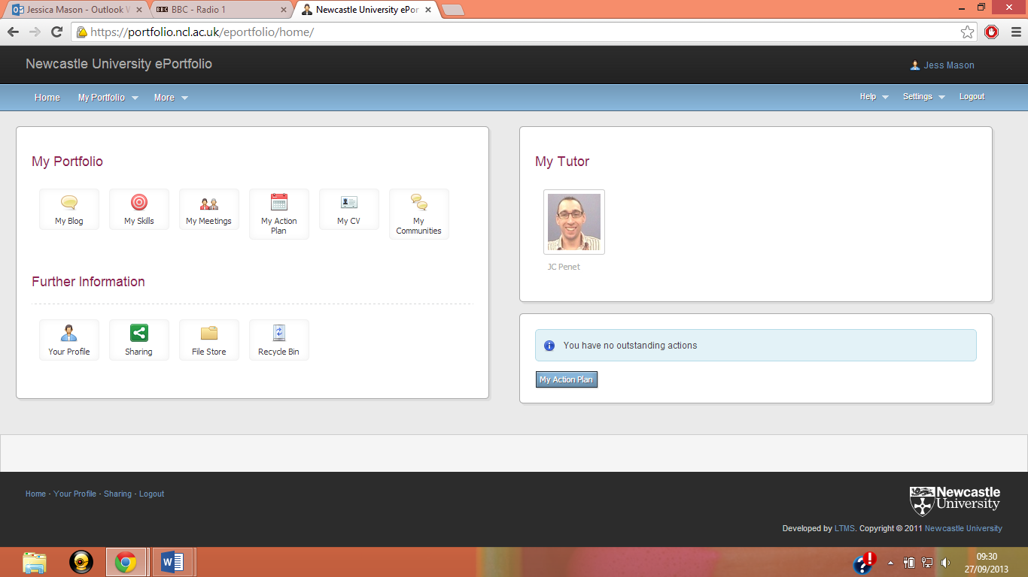

|  |  |
| --- | --- |
|  |  |

### 

### What is it?

The ‘My Skills’ section gives you a list of all of the skills that you see after you’ve written a blog. It is here that you can see whether you have evidenced a complete set of skills or if there are some which you could work on.

### Where can I find it?

The skills section can be accessed from your ePortfolio homepage.

### Why should I use it?

The skill section in your ePortfolio is a valuable tool for recording examples of skills to help with future job applications and interviews. For example, it will come in handy when asked questions such as, ‘*Give details of your main extracurricular activities and interests. What have you contributed and what have you got out of them?’* or, *‘Describe a team project you have worked on, the result that was achieved and how you achieved it.’*

### How do I use it?

|  |  |
| --- | --- |
| Once you have visited the ePortfolio home page and clicked onto ‘My Skills’, you will see this screen: |  |

The Graduate Skills Framework is a set of skills developed by the University with employers. When these skills are added to your knowledge from your degree programme, the Framework gives you the skills you will need for your life beyond university. Skills include subject knowledge and understanding, literacy skills, self-management skills, interaction skills and application of knowledge skills.

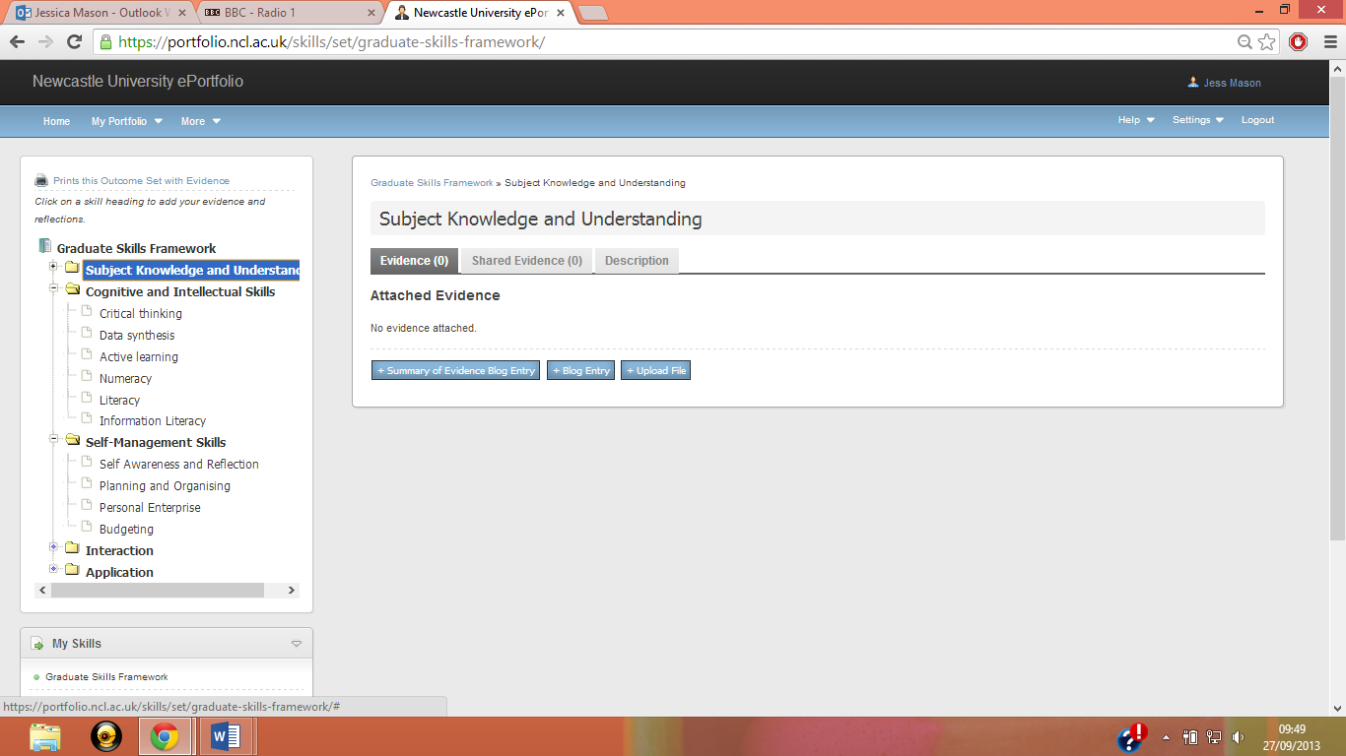When you click on one of the subheadings, you can see all of the items of evidence that you have entered for that subheading.

### What’s a Summary of Evidence?

Writing a ‘Summary of Evidence’ is a useful way to review all of the ways in which you have learnt the skill you are writing about, and reflecting on where you are now with that skill and looking forward to see how the skill could help you in the future.

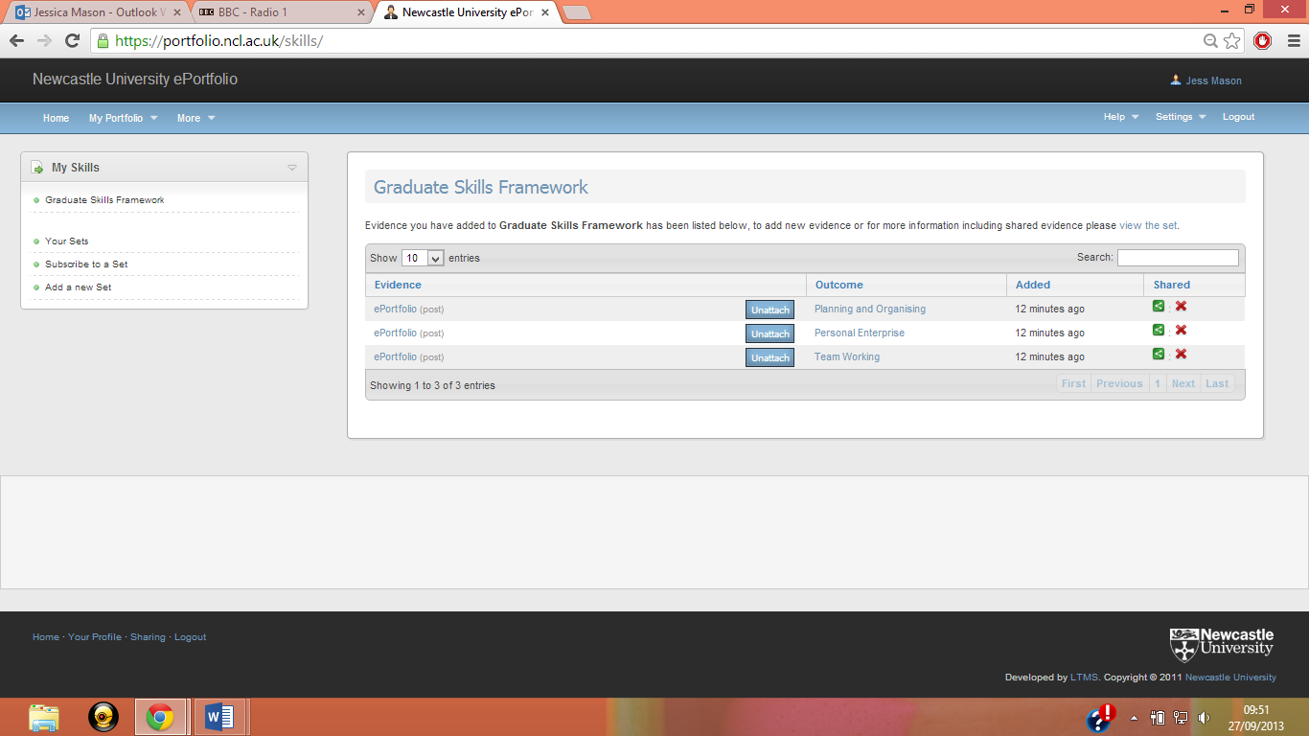When writing your summary of evidence for a skill, all the blog posts you tagged with that skill are linked to the bottom of the page. These can be seen under the heading, ‘Cross-Referenced Portfolio Items’. They’re useful as a quick reminder of what you did to develop all your amazing skills.

Write about general skills you have learnt throughout all of your academic and non-academic pursuits, citing specific times where you have evidenced these skills in your blog posts.

Here is a summary of evidence I have written as an example.

### 

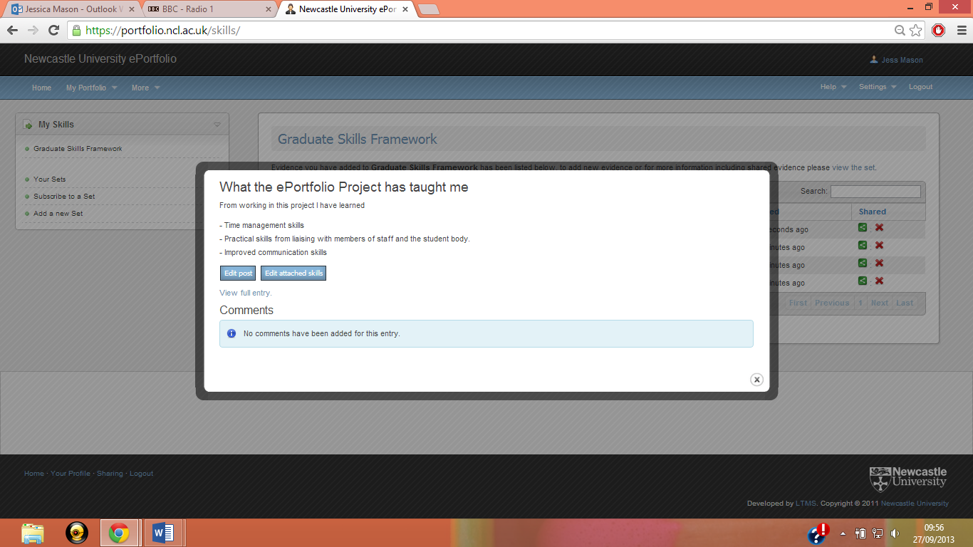

### What should I write in my Summaries of Evidence?

Writing your summaries of evidence helps you step back from daily student life and take a broader view of your skills development. This is sometimes easier said than done - you might find it useful to think about ‘reflecting on your learning’ as a step-by-step process. For example:

|  |  |
| --- | --- |
| **Step** | **Example** |
| **Level 1: Reporting**  Just describe what your experience was – don’t think too much about it. | I went to my groupwork project meeting. |
| **Level 2: Responding**  Well, what did you think about it? | It was rubbish. |
| **Level 3: Relating**  Start to think a little more deeply. | Some of the others hadn’t done their tasks and we didn’t get much discussion done in the meeting. And then two people left early. |
| **Level 4: Reasoning**  Ok, now start to explain **why** this happened and start linking it to things that have happened before. | Well, found the tasks easy because of the modules I took last year. Everyone else had done different modules last year and had only used the core text for this module, so they said it took longer to understand what we needed to do. The two people who left said their timetable had changed and they had to go to a lecture for a different module. |
| **Level 5: Reconstructing**  Now you can start drawing conclusions and making generalisations, then using these to become a better learner. | Through my group work project I learned the importance of early communication with group members to check that we all understood the task. I also gained experience of managing the timescale of a group project and updating work plans to fit in with changed priorities. |

Model adapted from: Bain, J.D., Ballantyne, R., Packer, J., and Mills, C. (1999). Using journal writing to enhance student teachers’ reflectivity during field experience placements. *Teachers and Teaching*, 5 (1), pp.51-73.

There are useful links in ‘My Skills’ as well, taking you to the Careers Service website and Ncl+. They can both help you find valuable work experience placements, volunteering and other important roles within the university, such as being a Student Staff Committee member for your course, which in turn will give you plenty of material to write about in your blog posts!

|  |  |
| --- | --- |
| Visit the Careers Service at: [www.ncl.ac.uk/careers](http://www.ncl.ac.uk/careers) |  |
| Visit Ncl+ at: [www.ncl.ac.uk/students/nclplus](http://www.ncl.ac.uk/students/nclplus) |  |

### What do other Newcastle students say about ‘My Skills’?

‘*Serves as a reminder for skills I’ve used when writing personal statements and applications for jobs.’*

*‘It encourages you to think about all the skills that you have gained.’*

# My CV

Build your CV!

|  |  |
| --- | --- |
| What is it? This is a section where you can build a CV, section by section. Where can I find it? The CV Section can be accessed from your ePortfolio homepage. |  |

### Why should I use it?

This is the really helpful section when applying for jobs, placements, graduate schemes or further study.

### How do I use it?

There are several categories which you can upload information to, including personal statement, qualifications and work experience.

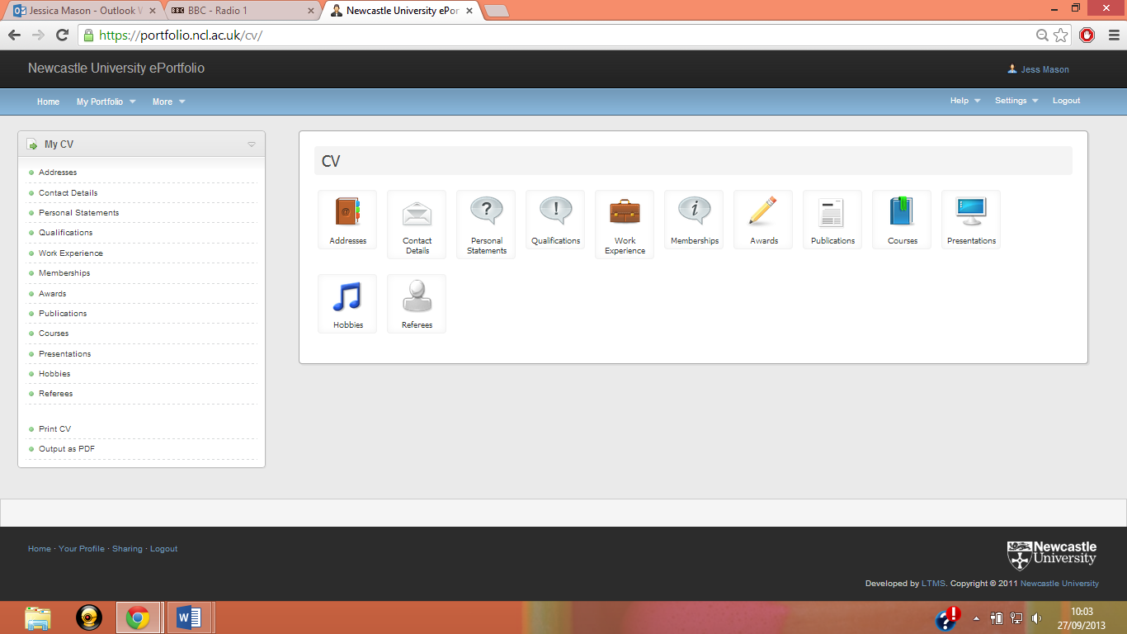

You don’t have to add information to every category. Start by choosing the ones most relevant to you.

|  |  |  |
| --- | --- | --- |
| It is really simple to start adding detail to your CV. Just click on the subtitle that you want to add information to, e.g. My Qualifications, and update some new details. You can also edit details at a later time. |  |  |

You can also attach blog entries, files and links to your CV.

When you have finished adding everything you want to your CV, you can generate a copy, which is a mock-up of how your final CV will look. You can print this as it is, or use it as a skeleton when designing your CV in Word.

Here’s my example CV to show you what it looks like:

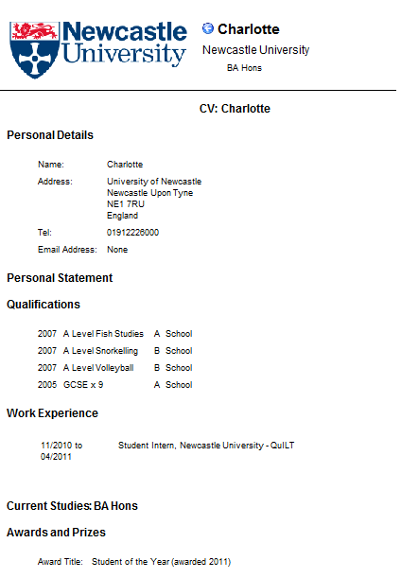

### Additional Links

Remember: different job applications may need different CVs. You can take your CV along to the University’s really friendly CV advisers! They’re in the King’s Gate building, and the drop-in clinics are run daily from 10am to 4:30pm.

See their website: [www.ncl.ac.uk/careers/jobs/applications/cv.php](http://www.ncl.ac.uk/careers/jobs/applications/cv.php)

# Your File Store

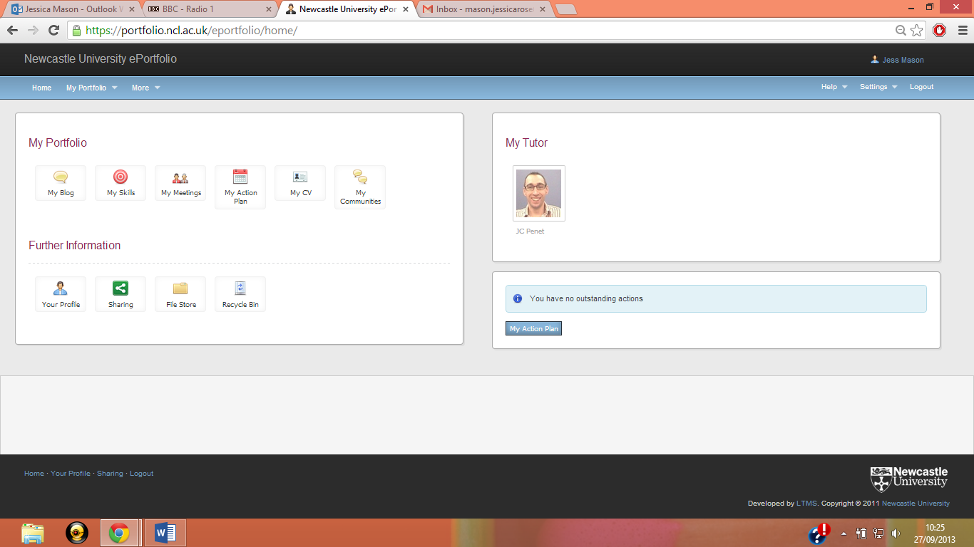

|  |  |
| --- | --- |
| What is it? ‘Your file store’ is an area where you can store documents online. This makes then accessible anywhere.  Any files you add to blog posts will be added into your file store automatically. Where can I find it? ‘Your file store’ is found through the ‘More’ tab at the top of your ePortfolio. |  |

### Why should I use it?

Uploading documents to one secure place online makes it easy to refer back to your learning experiences. You can then add these into any document you would like to, without having to trawl through your hard drive to find the right document!

# Action Plan

Task planning to help you organise

### What is it?

The ‘Action Plan’ is an online tool to help you plan and prioritise tasks.

### Where can I find it?

The ‘Action plan’ is found on your ePortfolio homepage.



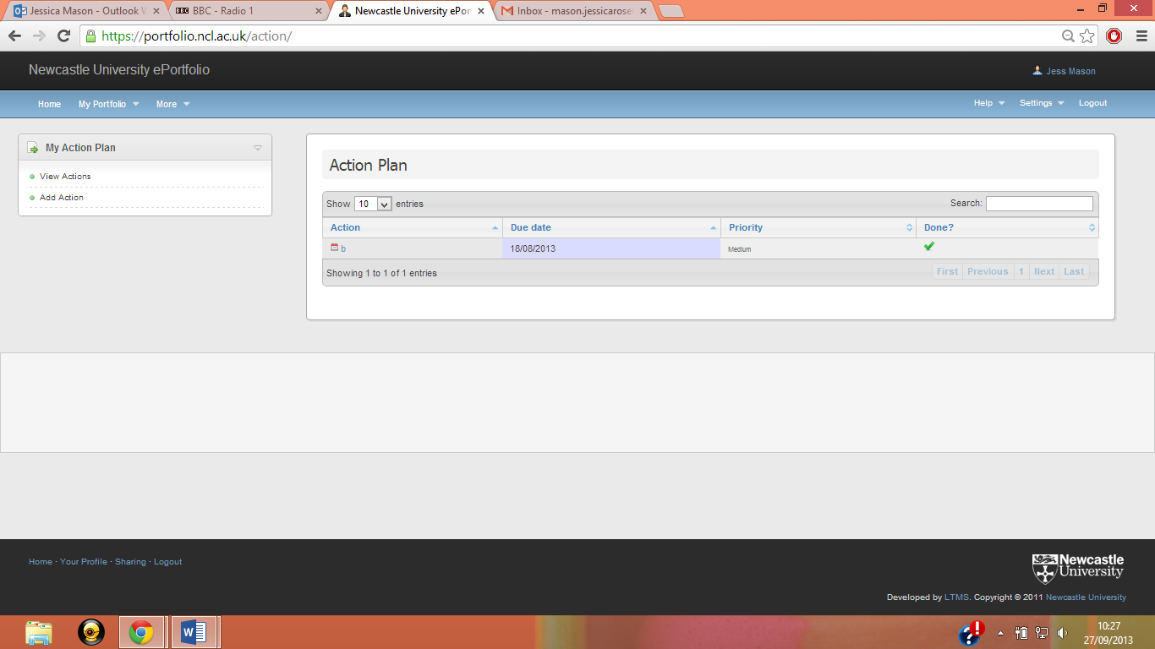

### Why should I use it?

As it is linked with your ePortfolio, you can use it for reminding yourself of deadlines for your group work, items of work you have stored on your ePortfolio that you want to complete, events that you want to attend, or anything else at all. You can also set a date for it to be completed by, and prioritise it as to how important the task is.

### How do I use it?

All you need to do is click on the ‘Add Action’ button and fill in the relevant boxes.

You can attach a file to an action, and share the action with your tutors.

Add a tick to the “Done” box when you’ve completed a task, and this will remove the task from your action plan.

# My Meetings

Preparing for and recording your meetings



|  |  |
| --- | --- |
| What is it? This tool helps you keep track of your meetings with your Personal Tutor. It helps you schedule a meeting, to make sure you and your Personal Tutor know when and where to meet. It also helps you prepare for each meeting by deciding what the meeting is about, writing notes on what was said, and planning for what you need to do next Where can I find it? Go to <https://portfolio.ncl.ac.uk> and log in. The ‘Meetings with my Personal Tutor’ section will be on the homepage. |  |

### Why should I use it?

You should use it to prepare for appointments with your tutor and keep an eye on your aims and achievements. Your meetings with your Personal Tutor will be more productive when you go into them knowing what you want to discuss.

Don’t worry if you can’t remember who your Personal Tutor is – there’s an automatic reminder on the system!

### How do I use it?

This part of the user guide is in 7 sections:

**1. Setting up a meeting**

**2. Inviting people to attend a meeting**

**3. Avoiding scheduling clashes**

**4. Adding meeting notes**

**5. Sharing files using meeting notes**

**7. Extra sharing features: ‘Sharing’ and ‘Profile’**

**1. Setting up a meeting**

On the ePortfolio frontpage, select My Meetings.



|  |  |
| --- | --- |
| * Select Record Meeting from the menu on the left of your screen. | ssc5_new.png |
| * Use this ‘Record Meeting’ screen to set the date, time, subject, and venue for the meeting. A calendar pops up to help you choose a date and there’s a pre-set menu of time slots, or you can type over these * Use the ‘Note’ box to add any notes regarding the meeting. Anyone invited to the meeting can read these notes. | |

Either a student or a Personal Tutor can set up a meeting. The organiser of the meeting gets a star next to their name: only the organiser of a meeting can delete a meeting record.

Your ‘My Meetings’ page will show a list of all meetings you’ve set up or been invited to.

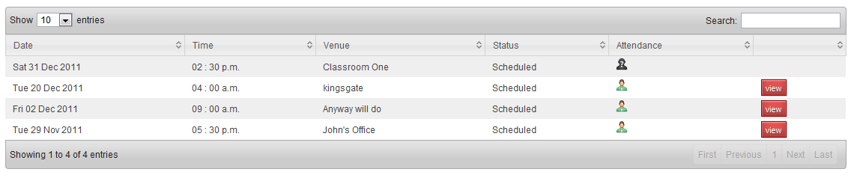

For information on adding public or private notes or files to a meeting record, go to the **5. Adding meeting notes** section of this user guide.

**2. Inviting people to attend a meeting**

Now that you’ve created a meeting record you can invite people to attend the meeting. If you’re starting from your ‘Personal Tutoring’ page click on the ‘view’ button to see a meeting record you have created. If you’ve just created your meeting record you’re already on the right page. So from your meeting record:

* On the left hand menu there is a list of the current attendees to your meeting. Select “add” to invite people to the meeting. The next screen will display people that have previously attended meetings with you. You can use the tab to search everyone. Use the green cross to add the person to your meeting.
* OR you can create a meeting with your Personal Tutor already added as an attendee. Click on your Tutor’s photo on the home page, on the left hand menu select ‘Meetings’, and then choose ‘Record Meeting’ you will notice you Tutor is now listed in ‘other attendees’ on the ‘Add Meeting’ form.

So although this Personal Tutoring screen is designed to support your meetings with your Personal Tutor, you can use it to record meetings with anyone in the University. If you want to use this to keep track of other group or one-to-one meetings you can – it’s completely up to you!

Remember that everyone is in control of their own ePortfolio and that ePortfolio is a secure system. When you invite someone to a meeting they have to accept your invitation to confirm their attendance at a meeting.

**3. Meeting slots**

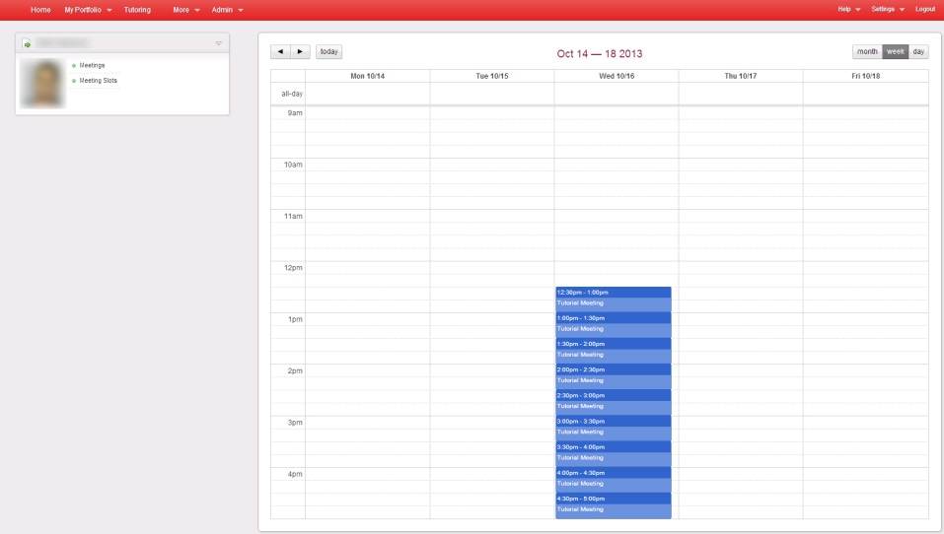Your tutor may create a set of meeting slots that you can sign up to. You will receive an email from the ePortfolio system. The link will take you to a screen displaying the available meeting slots in a calendar view. Click the meeting slot to set up a meeting with your tutor at that time.

**4. Avoiding scheduling clashes**

|  |  |
| --- | --- |
| If you try to add a meeting at the same time as another meeting you have created or confirmed your attendance at, you will see the red bar at the top. This displays a link to the meeting this record clashed with‘ | ssc3_new.png |
| If you add a meeting within 30 minutes of another, a warning message will be displayed. | ssc4_new.png |
| This is just a warning because of the proximity to another meeting you already have scheduled. Clicking the save button again will save this record. | |

If someone has invited you to a meeting at a time you already have a meeting, a yellow clash icon appears in your meetings list. The organiser won’t see the clash: only you will see the clash when you look at your scheduled meetings

Clicking on the clash icon will give a popup screen that shows both the meeting you have agreed to attend and the second meeting. You can choose which meeting to remove yourself from – you cannot be confirmed to attend two meetings at the same time.

Your ePortfolio does not include a scheduling assistant. You can remove yourself from a meeting, but if you want to suggest a new time for a meeting you should use talk to or email the other attendees.

**5. Adding meeting notes**

Your meeting record gives you and other attendees basic information about the meeting. Adding meeting notes is a way to share more information before and after the meeting. Notes can be either public or private, so you can choose who sees which notes.

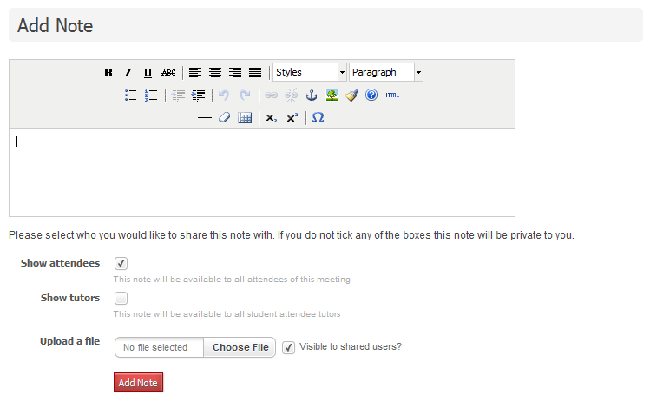

From the meeting record, use the ‘Add note’ box on the right-hand side to write a note. Each note shows the name and photo of the author, to keep track of who said what. Each note shows date and time it was written and notes are displayed in chronological order, with the newest at the top. All notes can be edited or deleted by the author of that note.

Notes are automatically shared with all attendees of the meeting. If you wish a note to be private, ensure there is a tick in the “Private” box.

**6. Sharing files using meeting notes**

If you want to attach a file, use the ‘Choose a file’ box to browse for the file on your computer, and then upload it.

# Sharing

A way to share some or all of your ePortfolio with anyone at Newcastle University.



|  |  |
| --- | --- |
| What is it? Your ePortfolio is yours. It can be useful to share parts of it with your personal tutor, other staff, or other students. All sharing functions in your ePortfolio are set up as a series of sharing groups. Where can I find it? ‘Sharing’ is located on the homepage on your ePortfolio. |  |

### Why should I use it?

It’s likely that you’ll want to let your Personal Tutor see some or all of your ePortfolio. This might be just one blog post or your CV, or it might be all your skills summaries. You might also want to share parts of your ePortfolio with other tutors or students. It’s a great way to get their views on what you’ve written. And unlike email, you can be sure that everyone is looking at the most up to date version of a document.

### How does it work?

You’re always in control of who can see what. For example:

Student A can share with Student B. This means B can see parts of A’s ePortfolio, but A cannot see B’s ePortfolio.

When Student B clicks on Student A’s ePortfolio they’ll see A’s profile. This is a shortcut to the parts of A’s ePortfolio that A has agreed to share with B.

When Student A clicks on B’s ePortfolio they’ll see B’s profile. From B’s profile they can request access to B’s ePortfolio.

### How do I use it?

From your ePortfolio homepage click ‘Sharing’. As a student you automatically have a ‘My Tutors’ sharing group. Your Personal Tutor is in this group. If you have more than one Personal Tutor they’ll all be in your ‘My Tutors’ sharing group.

Your personal tutor is the person that SAP (the University’s student records database) says is your personal tutor. If this is wrong, ask your School/Institute office to update SAP. You can’t use ePortfolio to change who your Personal Tutor is – if the information is wrong, or if your Personal Tutor changes, speak to your School/Institute office.

You can add as many sharing groups as you want. You can add as many people to a sharing group as you want. Remember that everyone you add must be a registered student or member of staff according to SAP.

To add a new sharing group:

* From the ePortfolio front page select ‘Sharing’
* Click ‘add group’ from the left hand menu
* Decide if this is a default group or not. If your sharing group is a default group, the sharing feature will be pre-ticked for this group every time you add a record. You can untick this default box at any time, but it will save you a click to keep your default settings up to date.

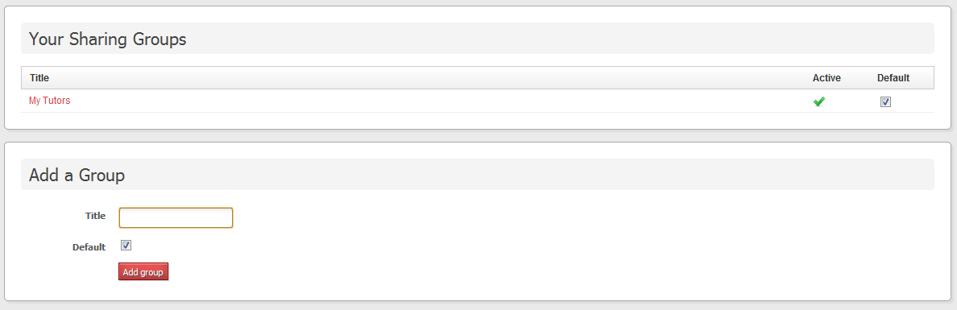

Now you need to add people to your sharing group. The search box links to all registered staff and students at Newcastle University. You can search by name or by username. Select the green cross to add them to the shared group.

If you want to share with your Senior Tutor, create a sharing group for them.

You can create a sharing group but then make this group inactive. This could be useful if you or your Personal Tutor is away from the University for a semester. Making a person or a group inactive is less permanent than deleting them – if you delete them you have to search and add them again, but if they’re inactive you just wake them up. Just tick or untick the ‘Active’ box next to one person’s name or the sharing group’s name.

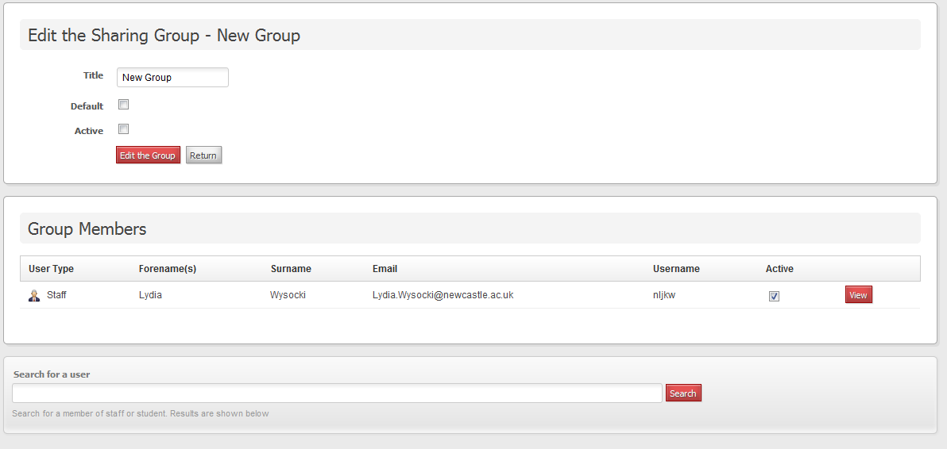

**What if I get a new Personal Tutor? Do I have to start all over again?**

This is where the ‘Active’ box becomes really useful. Add your new Personal Tutor to your ‘My Tutors’ sharing group. Then you can make your old Personal Tutor inactive (by unticking the ‘Active’ box), and all the sharing settings you created for them will be transferred to your new Personal Tutor. This is far quicker than manually transferring your sharing settings for each meeting note you’ve ever written, and means you stay in control of who has access to parts of your ePortfolio.

‘Your sharing groups’ also reminds you who is sharing their ePortfolio with you. Click ‘Sharing with me’ to see a list.

# Profile

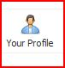Who you are!

|  |  |
| --- | --- |
| What is it? Your Profile is a summary of your ePortfolio identity. Where can I find it? ‘Profile’ is found on the front page of your ePortfolio. |  |

### Why should I use it?

To show other users who you are! Your Profile shows other ePortfolio users who you are, and helps you share parts of your ePortfolio with them. When you look at other people’s Profiles you’ll see their Smartcard photo, email address, and the School/Institute they belong to. All this information helps you be sure you’re contacting the right person, and helps make ePortfolio about *you* as a person – not just a student number.

### How do I use it?

From your ePortfolio homepage, click the ‘Profile’ icon. On the left-hand side of your Profile you should see:

* your name
* your email address
* the School/Institute you belong to
* your Smartcard photo.

You can customise the right-hand side of your Profile. Use the boxes to decide what you want other people to see on your Profile:

* the name you want people to call you
* a few sentences – or an image - about you
* the colour scheme you want to use for your ePortfolio.

# What to do now

Get Started Today!

It’s so easy to start building your ePortfolio!

* + - 1. **Get started!** Go to <https://portfolio.ncl.ac.uk>. 90%\* of students I surveyed agreed that the ePortfolio was easy to use – so get stuck in!

1. **Start a blog!** Write an entry on anything you’d like – write about how you’ve found your degree programme so far, what’s your favourite module you’re taking or an extracurricular activity that you do, like a part-time job or running the Great North Run.
2. **Link your entries to skills**. Tag your blog entries to skills, then go to My Skills to see how your skills record is developing. 80%\* of students surveyed agreed that ‘Using the ePortfolio helped me reflect on my learning and development’ which is a key part of the skills section! Remember, if you can’t remember what all of the skills mean, there is a full explanation of them here: [www.ncl.ac.uk/quilt/assets/documents/str-gsf-framework.pdf](http://www.ncl.ac.uk/quilt/assets/documents/str-gsf-framework.pdf)
3. **Start a community!** If you have a group task, start a community and invite people in your group to join. It is a great way to share information in an easily accessible way and 70%\* of students I surveyed agreed that ‘it was useful to see other perspectives in community discussions’.
4. **Keep it up!** One blog entry a semester won’t give a very good picture on all of the skills you’ve learnt. Try blogging once a week to start with, and watch your skills grow!

\*92 student users of ePortfolio pilot projects were surveyed.