PGR CoP – Admin Instructions

Key Concepts 2
Current Record 2
States (Stages of Progression) 2
Site Menu 2
Home Page 2
Search 2
To Dos 3
Admin User's Summary 3
List View 3
Ordering fields 4
Getting more information about a student 4
Progress Bars 4
Bulk Actions 4
Filters 5
Identifying students with no current record 5
Identifying students with no deadline set 6
Record View 6
Student Profile 6
Admin Actions on Records 7
Panel Members 7
Create Record 7
Edit Record 7
Mark as Lapsed 8
Exemptions 8
Paper Records 8
Upload on Behalf of 9
Modify State 9

PGR CoP can be accessed via ePortfolio: https://portfolio.ncl.ac.uk/
or directly for frequent users: https://postgrad.ncl.ac.uk/

Key Concepts

Current Record
The current record is ‘active’ and normally the latest annual progression. Students can have only one current record and only current records can be edited by students, and staff (this avoids potential confusion where a student might complete one record, but a supervisor completes a different one). When a new record is created the previous current record automatically becomes non-current. Administrators have the ability to set older records to ‘current’ (except fixed records imported as PDFs from the old system).

States (Stages of Progression)
There are several stages to progression, and therefore several ‘states’ that the progression record can be in during the period of progression. A record can only be in one state at any one time. The current state is indicated by the Progress Bars (see below), when viewing a list of students, or on the summary page of the progression record. Graduate School Administrators have the facility to intervene and Modify the State of a record (for example moving it on a stage). Filters on the List View let you quickly focus on records in a given State, for example all the records ‘with HoS’

Site Menu
The menu across the top of the system remains consistent throughout the system, and contains:
- Home – link to the home page of postgrad.ncl.ac.uk;
- List – view all students against the last viewed list (remembers your previous preferences);
- Reports – view selected reports, including supervisor/student meetings completed;
- Envelope – any messages sent from you or including you are listed here;
- i and Help – context-sensitive help throughout the system;
- ? and FAQ – Frequently Asked Questions and how to provide feedback.

Home Page

Search
Search for a student by tying in their name (or part of it).

To Dos
The Staff Home Page is focussed on To-Dos and shows the number of outstanding actions you have as Supervisor, Panel Member and if applicable as Head of School, Dean or Administrator.
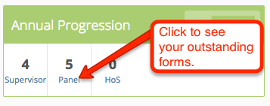
The To Do box will show you highlights of the number of outstanding actions against you according to your role(s) as supervisor, panel, HOS etc. Zero indicates no outstanding actions. Clicking on the link takes you to the List view and you can see the relevant students.

Admin User's Summary
Administrators, HOS & Deans also see an overview of Progressions at each stage for their School/Faculty. Clicking on the link takes you to the List view so you can see the relevant students - for example all those at the HoS stage. For those with access to Faculty there is an option for viewing a more detailed breakdown by Faculty/School.
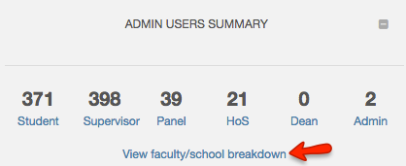

List View
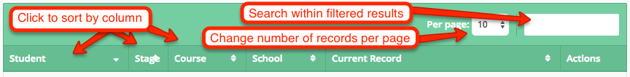
The table of students shows summary information, including the current state of progress, and any late (in red) or forthcoming (in green) deadlines attached to progression, for all parties involved in the process.
Hover over the progress bar to see further information about when the status last changed.

Ordering fields
To order results by a particular field, click on the field title. The up/down arrow will be replaced by an up or down arrow to indicate which field the results are being ordered by, and in which direction.
To change the direction, click on the field title again.

Getting more information about a student
Further information on the student is available by clicking on the student's name. This will tell you more information about their status of registration, and also their progress through the system.

Progress Bars
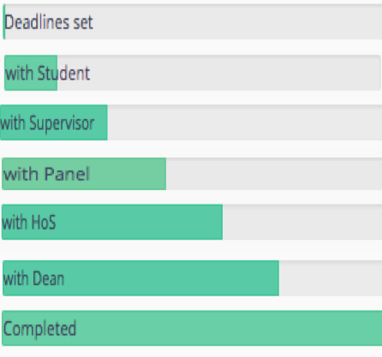
In addition there are less routine states:
'Uncompleted’ – Lapsed (students and staff cannot edit the forms)
‘with Admin’ - The main situation where this is used is where the Dean recommendation is ‘do not proceed’ and RSST/Graduate school will take the appropriate action (n.b. automated Email not sent to student for ‘do not proceed’)

Bulk Actions
Administrators only have access to 'Check All' and 'Uncheck All' options, although this is limited to 100 records to minimise risk of effecting large numbers of records by mistake.
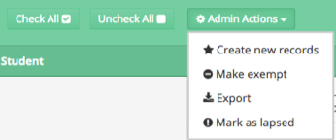
The bulk Actions include Export, which generates an Excel spreadsheet including the students checked in the list.
Additional admin actions allow student records to be updated (new records/setting deadlines created, exemptions and lapses to be recorded), and records to be exported. These actions and others can be applied to individual students via the Student Profile 'Admin' tab.
For details of specific actions see the section below: Admin Actions on Records

Filters
Filters that are currently applied will be shown in turquoise bubbles. Some filters are automatically applied when you view this page. The filters available depend on your role and privileges in the system.
To change further filters, use the small grey + symbol to the right of the current filters. This will expand the view to show the possible filtering options, from which you can choose your own specific filters. Note: the filters available to you are customised by role and your level of permissions in the system.
Any additional filters or field ordering that you apply in one session will be remembered for the next time you return to the system. In this way, you can customise your view to maximise efficiency in the system.
Lists from the home page To Do boxes have default filters applied, and these views will override any of your previously saved filter settings.
Filtering Compliments Progress Bars: a key feature of the system is that administrators can now quickly zoom in on outstanding actions using filters. For example filtering a list on all records where the supervisor deadline has passed - or the student deadline has passed.
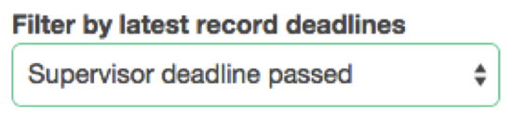

Identifying students with no current record
To view students who have no current progression record, reset the filters using the options at the top, then filter students using the ‘current record’ option to show only students without a current record.
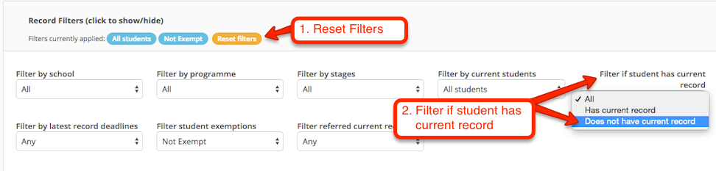

Identifying students with no deadline set
To view students who have no deadlines set, reset the filters using the options at the top, then filter students using the ‘record deadlines’ option to show only students with no deadlines set.
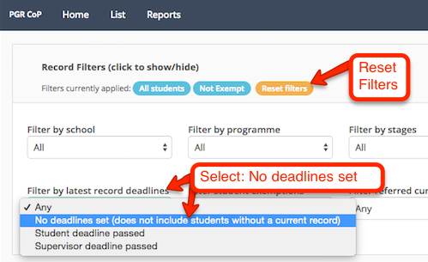

Record View
The Summary page shows the current status of the student's progression record, and if you have any actions waiting.
Each tab will indicate clearly whether action from you is required, or whether it is pending actions by others. Complete the relevant questions, and use the 'Confirm & Submit' button at the bottom of the form to complete and send it. Use the 'Save' option if you need to come back to it later.
Note: the options available depend on your role and level of privileges.

Student Profile
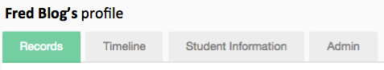
The student profile page has multiple tabs:
- Records - showing project approval, annual progression and nomination of examiners for the student, and at which stage they are in these processes.
- Timeline - a pictorial chronological summary of processes and stages of sign off.
- Student Information - detailing registration history and supervisors.
  - Please note: the information in this section comes from SAP SLcM. It is regularly updated but will be at least one working day behind, occasionally more.
- Admin - facilities to add panel members, set new deadlines and exemptions, and view uploaded documents from the student (restricted access).

Admin Actions on Records

Panel Members
To add panel members, from the Admin tab, use the ‘Add Panel members’ button to search for a member of staff on name or username. Select the appropriate member and add them.

Create Record
To create a new progression record, select the ‘Create new record’ button and fill in the relevant details including required deadline dates. Untick the ‘send email’ option if you do not want to generate email notifications. Save the form when finished.
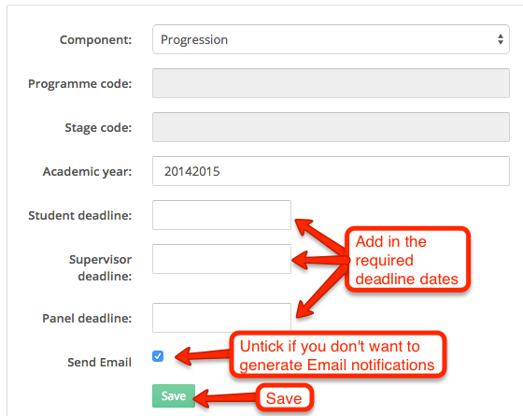

Edit Record
To edit the record, select the ‘Records Actions’ drop down button and choose ‘edit details’ from the list. Make the changes as for the record and save.
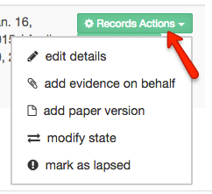

Mark as Lapsed
To mark a record as lapsed, select the ‘Records Actions’ drop down button and choose ‘mark as lapsed’. Confirm the details if you are sure.

Exemptions
Exemptions can be applied:
- to an individual via the Student Profile 'Admin' tab.
- to a group of students selected in List view.
To add an exemption, from the exemption section select the ‘Add Exemption’ button. Complete the relevant details and save.
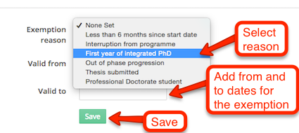

Paper Records
Online submission should be encouraged but if a paper form is received then this can be scanned-in and the file uploaded.
When the file is uploaded it automatically moves the record on to the next stage. For example if a supervisor form is added and the student has already submitted their form it will move to the state: 'with Panel'.
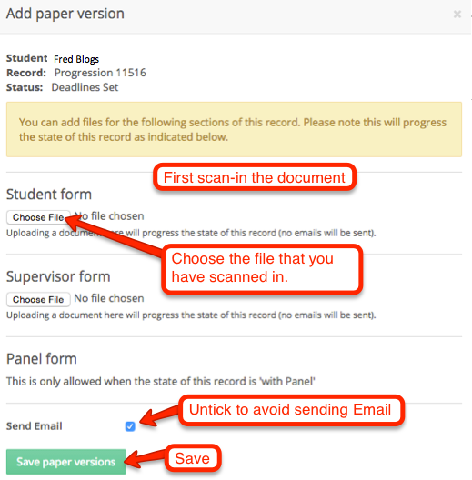

Upload on Behalf of
To add evidence on behalf of the student, select this option from the ‘Records Actions’ drop down button and choose the relevant file.

Modify State
This facility lets RSST/Graduate School staff move the records forward or backward a stage(s) in the process. A reason must be specified and this is displayed on the timeline, visible to all parties.
Go to the Panel Members area under the Admin tab of the Student Profile.
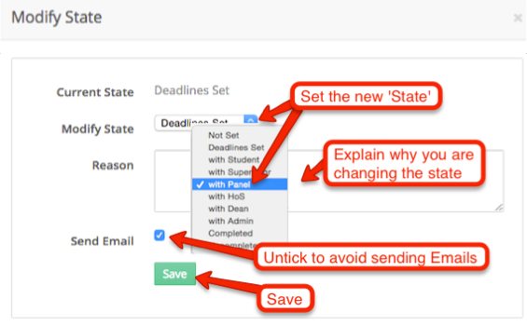
For example if a record is 'with Panel' you could set it back to 'with Supervisor'. This will effectively unlock the Supervisor form so that information can be added/revised. The Supervisor will then need to submit again in order for it to proceed to the Panel.

