

Integrating ePortfolio with Outlook

The meetings you record in ePortfolio can be accessed in your Outlook calendar using an iCal feed. This helpsheet will show you how to access this iCal feed and import it into Outlook.

From the drop-down menu at the top of ePortfolio homepage, select Meetings.

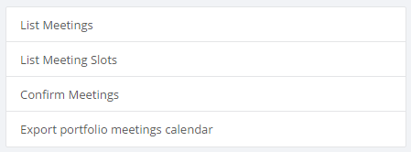

In the box on the left hand side of the page, select the option to “Export portfolio meetings calendar”

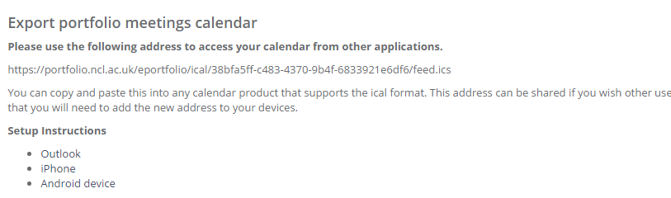

A box will pop up that will give you the address of your calendar feed. You need to select and copy your iCal feed address.

In Outlook, select Calendar



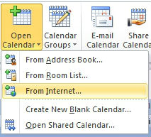

At the top of the page, select Open Calendar, then choose From Internet.

Paste the iCal feed into this box, click OK. A box will appear asking if you would like to “Add this Internet Calendar to Outlook and subscribe to updates”. Click confirm.

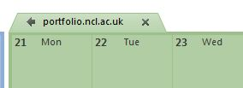

The new calendar will appear as a new shared calendar in Outlook. This calendar can be overlaid on the main calendar using the arrow to the left of the calendar.

It should be noted that this is a one directional feed. You will not be able to make any changes to the ePortfolio calendar in Outlook. Any changes made will be overwritten the next time the feed updates.