

The Blog

‘It is not sufficient simply to have an experience in order to learn. Without reflecting upon this experience it may quickly be forgotten, or its learning potential lost. It is from the feelings and thoughts emerging from this reflection that generalisations or concepts can be generated. And it is generalisations that allow new situations to be tackled effectively.’[1]

The blog is the main tool in the ePortfolio and many of the tasks undertaken will utilise this tool. It enables reflection, discussion, and the ability to add evidence against competency frameworks.

You have ownership of your blog and can choose who to share each post with. You can keep your posts completely private if you wish to. Your blog is presented in a series of posts that are in a chronological order, with the latest posts at the top of the page.

To access the blog element of your ePortfolio select Blog from the drop-down main menu at the top of the page.

Adding a blog entry

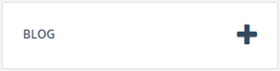

Blog entries can be made from several areas of ePortfolio. You will see the adding blog entry graphic on the frontpage, the blog page, communities, and the skills section.

* Title – This is the title of your blog post.
* Blog Text – This is where you should type the main content of your blog post.
* Everyone in the University – tick this box to make the blog post public.
* Tags – this is where you would enter keywords to describe your blog posts. Use accurate keywords as this will enable more effective indexing and searching.
* Communities – Communities are online collaborative spaces, where ePortfolio users can share blogs and comment on other members’ blogs. If the blog post is to be shared with any of the communities, use this area to select which communities can see the post. You will only see Communities that you are a member of.
* Skills – you can align a blog post with a skill from a skill set, or competency framework. All undergraduate students will be subscribed to the Graduate Skills Framework



* Shared group - if you wish to share this post with any of your share groups, ensure that group is ticked. If you do not see this option, you are not a member of any share/supervision groups.

(To find out more about share groups and supervision groups, please access the helpsheets here – https://portfolio.ncl.ac.uk/help/helpsheets)

* Upload a file – You can add a file to go along with your post. Your file will be shared with any of the groups you are sharing the blog post with.

Note: If you save a partially completed blog post and have some sharing options enabled (either share group, supervision group, or community), the partially saved blog post would be seen by those you are sharing with. They will see a live link to your post, so if you edit it later, they will see the updated version.

Viewing posts from other people

In the Blog area, you will see your blog stream which consists of your blogs and any other blogs that have been shared with you. You can filter these blogs using the box on the left hand side labelled ‘Filters’.

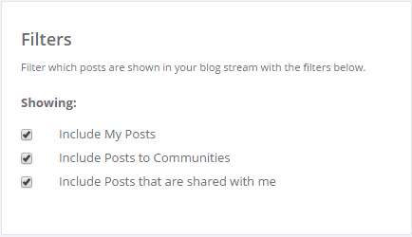

So if you only want to view your own blog posts, you can untick “Include Posts to Communities”, and “Include Posts that are shared with me”

You can also view any comments on your blog posts either within the post, or using the comments tab at the top of the blog area.



Tags

By tagging your blog posts with relevant keywords you can use the tag section to filter your blog and display only the posts with that tag attached.

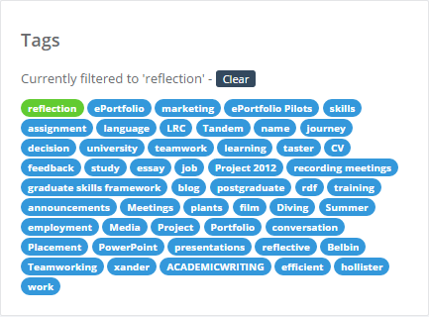

Download

You can use the download button on the top right of the blog area to download your blog posts as a pdf, or as a rich text format document which can be edited in Word. You may want to do this to help with job applications, writing up projects. etc.



If you have filtered your blog using tags, selecting download will download only the posts containing those tags.

1. Gibbs, G. (1988) Learning by Doing: A guide to teaching and learning methods. Oxford: Oxford Polytechnic Further Education Unit.