

## Senior Tutor Report

To create the Senior Tutor report, select the Senior Tutor option from drop down menu at the top of ePortfolio. If you do not have this option in the drop down list, contact your School administration team.

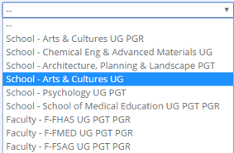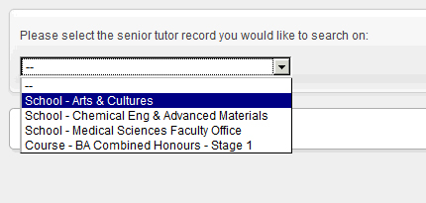

The report can be run at programme or School level. The options available to you will depend on the access level rights granted. Select which section the report should be run.

The main page has a collection of drop-down menus that you can use to filter the list of students. Choose the filter you wish to use and click the button labelled “Show Students”.

For example, you can choose a particular course, and stage 1, and view any students that have not had a meeting in the first four weeks of semester 1.

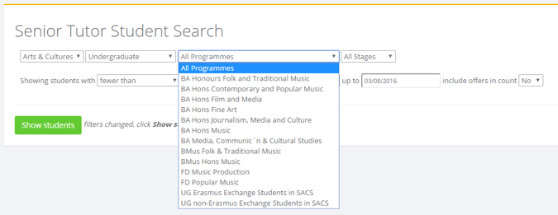

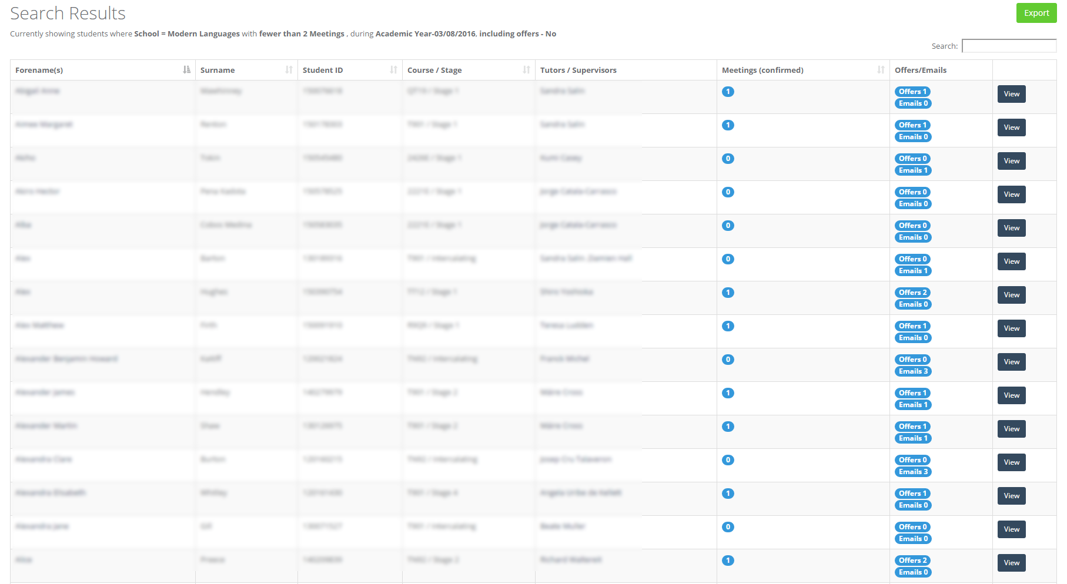

The results of the report will be shown as in the table above. This report can be exported to a .csv file using the Export button at the top right hand corner of the search results.

The email / slots column shows the number of meeting slots that the student has been offered, or any emails sent via ePortfolio to the student by the tutor. Please note the data displayed for Emails and slots offered is not altered by the dates set in the filter.

By selecting a student name, the details of tutor meetings can be seen, but the notes are not accessible. The tutor meeting record is a confidential record between the tutor and the tutee. Others can view the meeting record only with the informed consent of the student.

For more information about the confidentiality of the meeting record, please access this web address. <https://portfolio.ncl.ac.uk/help/confidentiality/>

You can filter the results by tutor, by clicking on the tutor’s name. This will show all that tutor’s tutees and will show all the tutor meetings that have been recorded.