# 

## Supervision Groups

Supervision groups can be created by staff and allow easy sharing between the members of the group and the supervisor.

Once created, the supervision groups allow the supervisor to set up meetings, communities and email the members of the group. The group members will be able to share their portfolio content and set up meetings with the supervisor.

Supervision groups will look and behave differently for staff and students:

#### Supervisors (staff)

* Can see all the members of the group
* Can share portfolio items easily with all the group members
* Can create a community from the group to allow for collaboration between all learners
* Can create a group meeting with the members of the supervisory group
* Can email the members of the group from within ePortfolio

#### Students

* Can only see the Supervisor (unless the supervisor sets up a community)
* Can share items easily with the supervisor
* Can record and view meetings with the supervisor
* Cannot remove themselves from a supervision group

#### Creating a supervision group

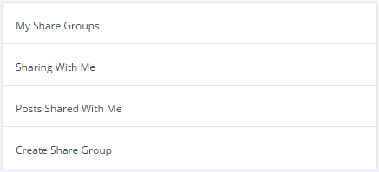

To create a supervision group, go to Sharing from drop-down menu on the front page of ePortfolio.

In the panel on the left hand side, select Create Share Group. You will be given the option to create a standard share group or a supervision group. Choose supervision group.

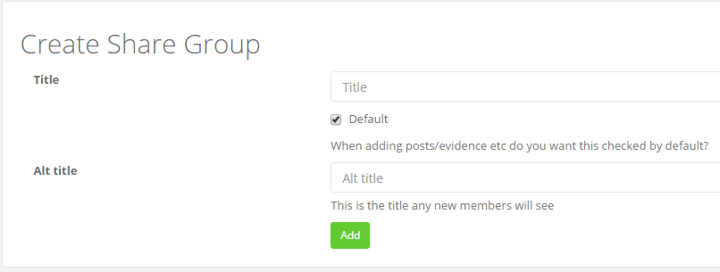

Give the supervision group a name. This is the name of the group that will appear in **your** ePortfolio. The group can have a different name in the members’ portfolio by adding something into the Alt title section.

For example, you may want to call the group "Supervision Group" but this would be confusing for the students, so adding "My Supervisor" into the Alt title section would resolve this. Consider the name of the group carefully, you could include the academic year if it is a reoccurring group. For example “Placement Students 2014/15” and the Alt title for the students “MOD018 Placement Supervisor”.

The default option on this screen relates to whether you want the share option to be ticked automatically in the areas of ePortfolio that can be shared.

#### Adding members to a supervision group

You can add members to a supervision group individually or by module / programme code.

Once you have created the group, you can access a tab labelled "Manage members". In the search box enter the name of a member of staff, a student, or a module code. If you are using a module code, all students under that code will appear. You can pick particular students to add using the green cross next to each name, or you can use the "Add all" button to add everyone to the supervision group.

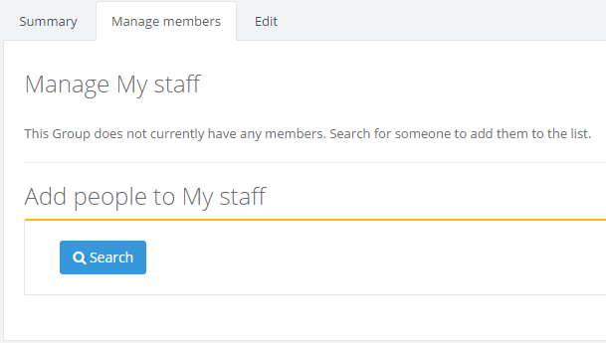

Once members have been added to the group, it will be displayed in a tab on the front page of ePortfolio. By clicking on the group, a popup box will appear that will allow you to see any items that have been shared with / by you over the last 14 days. You can also do the following:

* View Group

This will allow you to see all the items that have been shared with and by group members. You can filter to view specific members and the items they have shared.

* Create a Group Meeting

Group meeting records can be created with all the group members as attendees. This is only possible for groups of 15 or less.

* Create a Community

This will create a community with all group members automatically enrolled into it. This will facilitate sharing between members (see separate help documentation for Communities). Group members will be able to remove themselves from the community if they wish to.

* Send an email to the group members

#### Sharing

Once the supervision group has been created, it will appear in the share areas in all members’ ePortfolios. Supervisors will have the share name they gave to the group, while members will have the alt title share name in their ePortfolio. If the box is ticked, that part of the ePortfolio will be shared with the supervisor / students. If the staff member shares with the group, all the group members will be able to see the shared item. If the student shares with the supervision group, only the supervisor will be able to see the shared item.

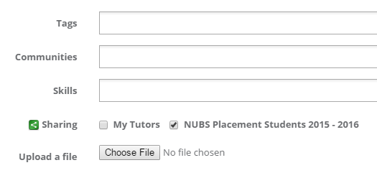

For additional support information relating to supervision groups, please access our Frequently Asked Questions section at <https://portfolio.ncl.ac.uk/help/supervisiongroupsfaq>

You can receive further training with a Supervision Group webinar run by LTDS. You can find out more details about this here: <http://www.ncl.ac.uk/ltds/about/training/ePortfolio/workshops/supervisiongroups/>