# 

Skills

Many programmes have a set of standards, or skills, also known as competency frameworks. Students need to demonstrate and show evidence they have met these standards. The skills area allows students to manage the professional standards they subscribe to and the relevant evidence.

Graduate Skills Framework

Students are automatically subscribed to the Graduate Skills Framework. This framework “provides the opportunities for students to acquire the following learning, working and life values:

* Enable personal goals and aspirations to be met through self-directed continuous learning
* Apply a can-do attitude to taking calculated risks and challenging personal boundaries
* Create and cultivate cross-cultural relationships to develop knowledge, skills, understanding and opportunity”

This is underpinned with a set of skills and competencies that make up the Graduate Skills Framework. For more information on the Graduate Skills Framework please access http://www.ncl.ac.uk/ltds/assets/documents/str-gsf-framework_000.pdf.

Viewing your skills sets

To view which skill sets you are subscribed to, go to the Skills section from drop-down menu at the top of ePortfolio. The skill sets you are subscribed to will be visible in the left hand panel. If you are a taught student, you will see the Graduate Skills Framework, if you are a Postgraduate Research student, you will be subscribed to the Researcher Developer Framework.

Subscribing to a skill set

To subscribe to a skill set, go to the Skills section from drop-down menu at the top of ePortfolio.



In the top right corner select “Manage Subscriptions”.

You can either search, or browse for the required skill set using the “Browse Skill Sets” area.

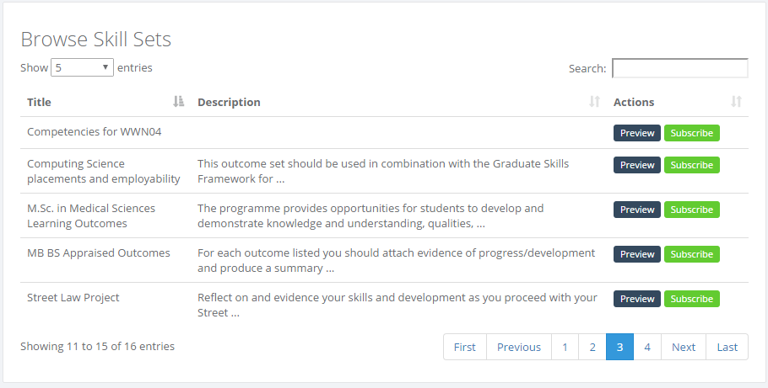

Use the preview button to view the skill set before subscribing, and once you are sure you have the correct set you can subscribe.



Creating a custom skill set

Staff are able to create their own skill sets in ePortfolio to be used with students. Students cannot create their own skill sets.



To create a skill set, use the Add Set option from the main Skills page.

On the next page, add the title and a description of the set. The skill will not save without an entry in the description phase.

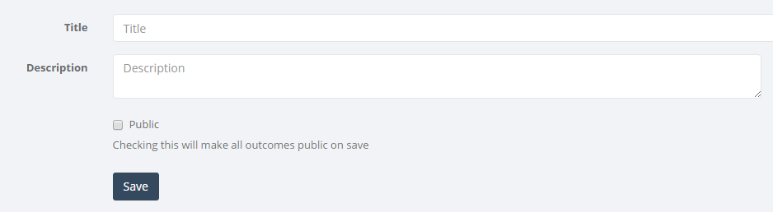

Once you have saved your title, it will appear on the page with a cross next to it. Use this cross to add some sub-sets to the skill. Use the cross to the left of the title to open up the sub-sections of the skill set.



Skill sets are often made up of (sub) folders with competencies within the folder. To create a folder or subfolder, add the folder name as you would a skill. Click on this folder name before adding more competencies to ensure those competencies go into the specific folder.

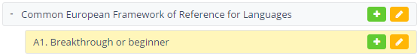

Once you have built your skill set, select the top level name for the skill, then click on the pen tool. Tick the public box to make your skill set live.

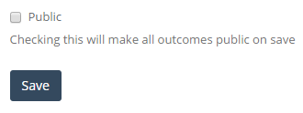

You can access further training on skill sets through a 15 minute webinar run by LTDS. For more information please go to <http://www.ncl.ac.uk/ltds/about/training/ePortfolio/webinars/skillsets/>