# 

## Notification Preferences

ePortfolio will notify you by email when particular events happen within the system. These emails can be very useful to help you manage your work but there is the potential to receive too many emails. You can amend the purpose and frequency of these emails within the notification preferences section.

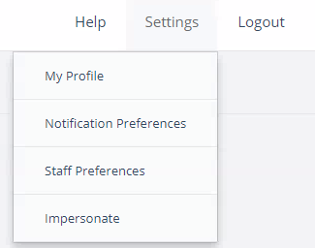

To access this, choose Settings in the top right corner of ePortfolio, then Notification Preferences from the drop down menu.

A list of the possible events that trigger email notifications will be displayed. The page is split into two sections – Meetings and Blog.

#### Meetings

You cannot opt out of notifications from this first section. You will always receive an email informing you of invites to meetings or when notes are added to a meeting that you are an attendee of. You can change how often you receive these emails though. Use the drop down items found to the right of the each notification option.

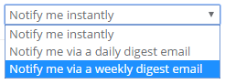

#### Blog

You can opt out of the notifications from this section. To opt out, untick the box next to the name of the notification. You can change the frequency of the emails sent by using the drop down in the same way as in the meetings section described above.

