  - Granting access to meeting records
Throughout your time at University, your personal tutor may change. For example, if your tutor is on research leave you will have a different personal tutor during that time. ePortfolio allows you to grant your new tutor access to previous meetings records.

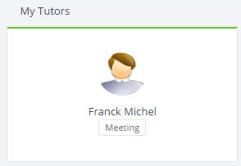

To grant someone access to a meeting you have attended, click on their image.

This will take you through to the users profile page. With the meetings tab selected, you will see there is the option to “Grant Meeting Access” at the bottom of the meetings.
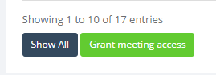

The next page will show the meetings that you can grant access to. Any meetings where the person you are granting access to is already an attendee will not be listed. Add a tick into the box to the left of the meeting details to grant access. Once you have selected the relevant meetings, select “Confirm” to grant the user access.
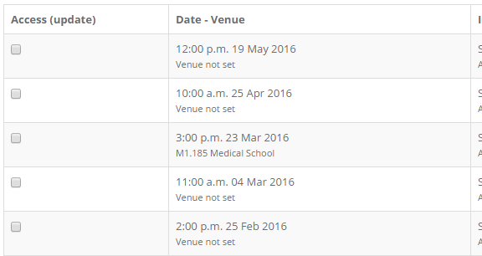

Once this access has been granted, this new person will be added as a viewing non-attendee. They will be able to see the meeting record, including any notes, but they will not be able to edit the meeting or add their own note to this meeting.
  - Confidentiality
The notes of a tutor meeting are completely confidential. Any notes in a meeting in ePortfolio will only be able to be viewed by attendees of the meeting, unless the student permits someone else to view them. For more information about the confidentiality of meetings, please follow the link below.
https://portfolio.ncl.ac.uk/help/confidentiality

